CIRCUIT DIAGRAM

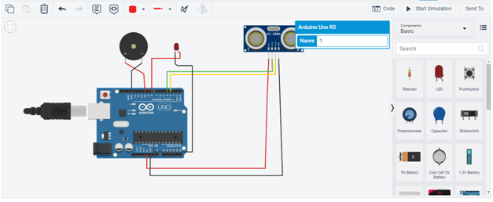

Code:

int trigpin=4;

int echopin=3;

int buzzerpin=10;

int time;

int distance;

void setup()

{

pinMode(8,OUTPUT);

pinMode(3,INPUT);

pinMode(4,OUTPUT);

pinMode(10,OUTPUT);

Serial.begin(9600);

}

void loop()

{

digitalWrite(trigpin, HIGH);

delayMicroseconds(1000);

digitalWrite(trigpin, LOW);

delayMicroseconds(1000);

time=pulseIn(echopin,HIGH);

distance=(time\*0.034)/2;

if(distance<=10)

{

Serial.print("Distance= ");

Serial.println(distance);

digitalWrite(8,HIGH);

delay(1000);

digitalWrite(10,LOW);

delay(1000);

}

else

{

Serial.print("Distance= ");

Serial.println(distance);

digitalWrite(8,LOW);

delay(1000);

digitalWrite(10,HIGH);

delay(1000);

}

}

OUTPUT

